Instructions for filling out the WCVI Stream Inspection Log (SIL)
The WCVI Stream Inspection Log (SIL) is the standard DFO form that has been modified for surveys on the West Coast of Vancouver Island. It is essential that the SIL is filled out completely and correctly for every stream visit. Surveyors should review the SIL field definitions and seek clarification from the DFO stock assessment biologist on any unclear sections. The field definitions are given for each page of the SIL below. Make sure you are using the most up to date version of the SIL.

C.1 Front - Environmental conditions
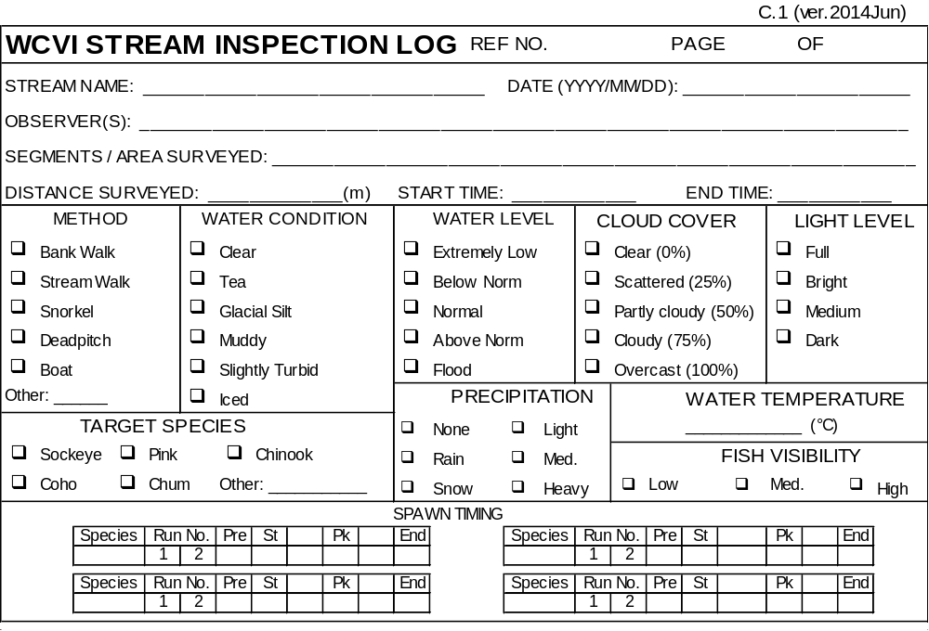
STREAM NAME: Record the common name of the stream
DATE: Record the date of the survey in YYYY/MM/DD format
OBSERVERS: Record the names of all crew conducting the escapement survey
SEGMENTS / AREA SURVEYED: List the range of segments surveyed starting with first section surveyed. This should always be the same, unless a reason is given on the following comments page
DISTANCE SURVEYED: Record the distance of stream length covered in the survey, in meters (m)
START / END TIME: Record the start and end of survey (not travel time) in local time using 24 hour clock (i.e. 09:30 / 15:00)
METHOD: Record the inspection method. If a combination of methods are used, checkmark all appropriate boxes.
WATER CONDITION: Select the water clarity conditions that best describe the system during the survey
WATER LEVEL: Select the water level category that best describes the water stage relative to average survey conditions.
CLOUD COVER: Check category for % of cloud cover that best describe the conditions during the survey (Table 1).
Table 1. Category descriptions for cloud cover
Cloud cover category | Conditions
Clear (0%) | Clear or with a few isolated clouds
Scattered (25%) | Scattered cloud cover about 25% of the sky
Partly cloudy (50%) | Clouds cover about 50% of the sky
Cloudy (75%) | Clouds cover about 75% of the sky, but some sky is still seen
Overcast (100%) | Clouds cover the sky, includes foggy conditions

LIGHT LEVEL: Check category for light level according to conditions described in Table 2. Light level may not necessarily depend upon cloud cover (i.e. thin clouds produce bright daylight).
Table 2. Category descriptions for light levels
Category | Conditions
Full | Direct sunlight, shadows are well defined
Bright | Non-direct sunlight (hazy, light clouds), shadows visible, visible outline of sun
Medium | No shadows, but distinguishable areas of bright and dark in the sky, no outline of the sun
Dark | Very dim light, no shadows, no bright area in the sky from the sun

TARGET SPECIES: Check the primary species for which the survey is conducted. More than one species may be chosen.
PRECIPITATION: Check category for type and amount of precipitation, or check “none” if there was no precipitation.
WATER TEMPERATURE: Record the water temperature in Celsius using a thermometer. Refer to stream specific protocols for where this measurement should be made.
FISH VISIBILITY: Check category that gives an overall estimate of conditions for that survey. Fish visibility integrates the effect of discharge, light level, clarity and precipitation on the ability of the surveyor to see fish.
SPAWN TIMING: Write in the species that is being enumerated in the box under species and check one box to indicate timing as; arrival to the river (Pre; no pairing observed and fish holding in tidal portion of river, pools or runs), start (St; some pairing on spawning gravel and no dead fish observed), midway between start and peak, peak (Pk), midway between peak and end, and end (End; no spawning fish remaining, possibility of a few live fish but all are near death). The form can be used for up to four species in the system and up to 2 different runs. Indicate which run the survey is for if more than one run in system.

C.2 Back – Environmental conditions (continued)
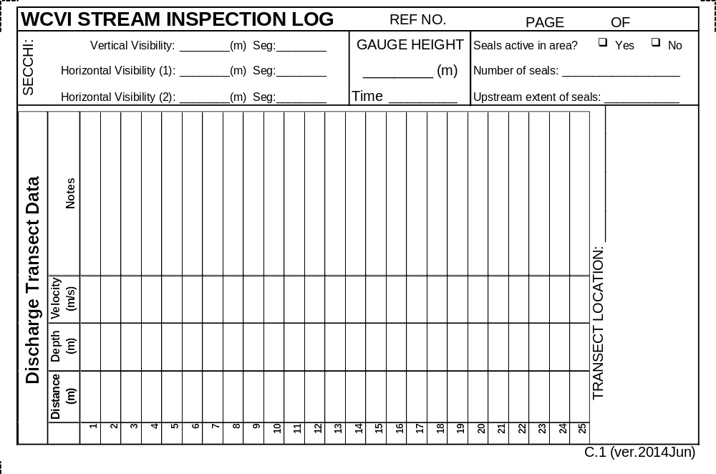
SECCHI:
- VERTICAL VISIBILITY / SEG: Using the provided Secchi in a deep pool (see stream specific protocols for instruction on location), measure depth at which the disc disappears and reappears. See Appendix A on how to use a Secchi. Record the river segment where the measurement was made.
- HORIZONTAL VISIBLITY (1 / 2) /SEG: Using the provided Secchi in a slow moving glide or shallow pool, measure distance at which the disc disappears and reappears as two swimmers move apart then towards each other. See Appendix A on how to use a Secchi. Horizontal visibility should be measured twice during the survey (i.e. at the start and finish). Record the river segment where the measurements were made
GAUGE HEIGHT: Record stream gauge level (i.e. 1.43 m). If water level is below the stream gauge, extend a line (i.e. line from throw bag) from the gauge to a stream location with water, use level to make the line horizontal, and measure the distance from the water surface to the line to give a negative gauge height reading. Also record the time the gauge level was recorded.
SEAL ACTIVITY: Check whether seals are present in the survey area or estuary
NUMBER OF SEALS: Count of the seals present in the survey area or estuary
UPSTREAM EXTENT OF SEALS: Note the upstream extent of seals observed.
DISCHARGE TRANSECT DATA: To estimate discharge, follow the methods described in the Guide to Obtaining Stream Discharge and Water Clarity Parameters for Snorkel Survey Crews (Appendix A). For a given number of locations across the stream, record the distance from the starting point, the depth, and the velocity. Notes may include the location and side of the stream (i.e. left or right side relative to view downstream). Once a stage-discharge relationship covering the range of flows at which surveys can be conducted is established and discussed with the stock assessment biologist, a stage measurement is sufficient to estimate discharge.

C.2 front / back – Observations
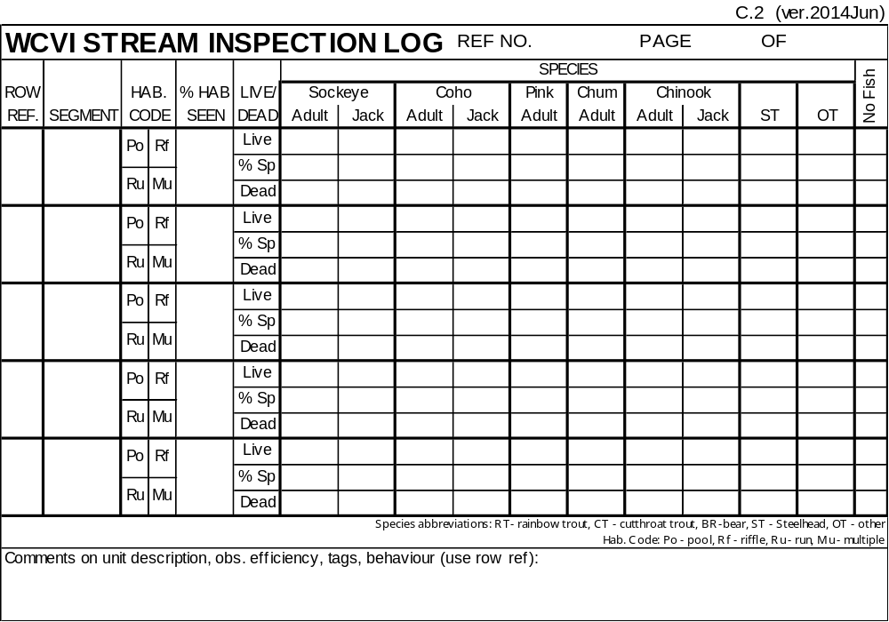
On each row record:
ROW REFERENCE: On C.2 number rows sequentially, starting with one. For example, the first C.2 used will have rows 1 through 5 on the front, and rows 6 through 10 on the back. The second C.2 used will have rows 11 through 15 on the front, and so on. The number may be used to reference comments to a specific row.
SEGMENT: Record the segment using marker numbers. For example, for observations between markers 7 and 8, you would record “8-7” if moving downstream or “7-8” if moving upstream. Generally numbered starting from the top of the survey section anywhere from 4-3 (Leiner) to 19-18 (Moyeha). It is important to use the same segments as previous weeks/years. Keeping track of which segments held fish, and keeping the sections consistent allows us to look at the distribution through the river and track changes in distribution over time.
HABITAT CODE: Circle the habitat type referring to the abbreviations at the bottom of the page (Po-pool, Rf-riffle, Ru-run, MU-multiple). If you are able to do so, then each row of the data form will represent a single habitat type within a given segment. However, in some cases, habitat type will change too frequently to allow this approach. If this is the case, then record your counts by segment and block out the (Mu) box for “multiple habitats”. The (Mu) box is most often use to indicate when no fish observed in an entire section.
% HABITAT SEEN: The percentage of a survey unit or habitat unit that you can actually count fish in. For example, you may only be able to see the top third of a particular pool; in this case, the % habitat seen would be 33%. Glare off the water surface may obscure 20% of a riffle from your view so you would choose 80%. In an aerial count, you may only observe 70% of the river as you are counting due to stream cover.
LIVE / % SPAWNING / DEAD: For each species, record the number of live fish observed, the % of those actively spawning, and the number of dead fish observed. Do not expand this count.
OT (OTHER SPECIES): List the other species and the number observed. Extra species can be recorded in the comments section. For species abbreviations look to the bottom of the page.
NO FISH: If no fish (live, dead, or both) are observed in the habitat unit surveyed, check the appropriate box or boxes.
COMMENTS: At the bottom of the C.2 record any notes pertinent to each segment such as observation conditions, spawning behaviour, tags observed including if tags are on live/dead fish, loose, or if dead fish were checked for tags or tagloss. If you run out of space, continue comments using the C.3 comment sheets provided.

C.3 front / back – Notes
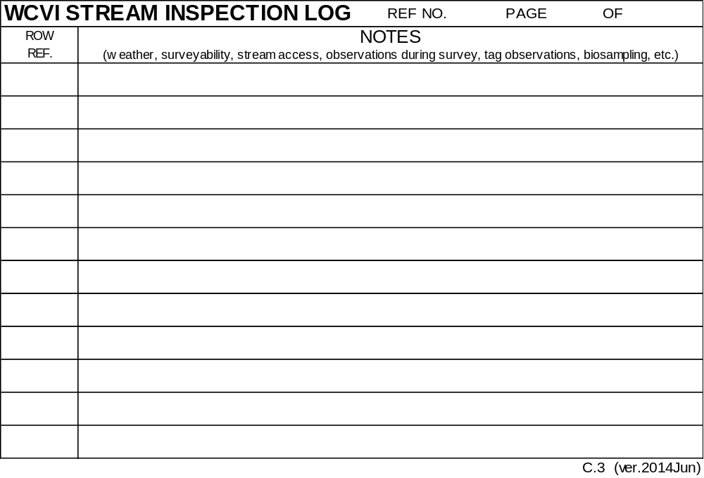
Use the “Notes” pages for any comments and extra observations or conditions that may affect the survey or quality of observations. You may also include extraneous biological information, such as bear sightings, multitude of fry in stream, visible redds, etc. Tag sightings should be recorded here, as well as the sample numbers and segments associated with any biosampling. If relevant, list row reference referring to those used on C.2. Attach additional C.3 pages as needed.

C.4 front – Post survey checklist, notes and totals
At the end of the survey make sure that the “Ref No.” from C.1 has been recorded on both sides of every page. Record the the page number and total page number on both sides of all survey cards. Use the checklist as a guide to make sure that the SIL has been completed correctly.

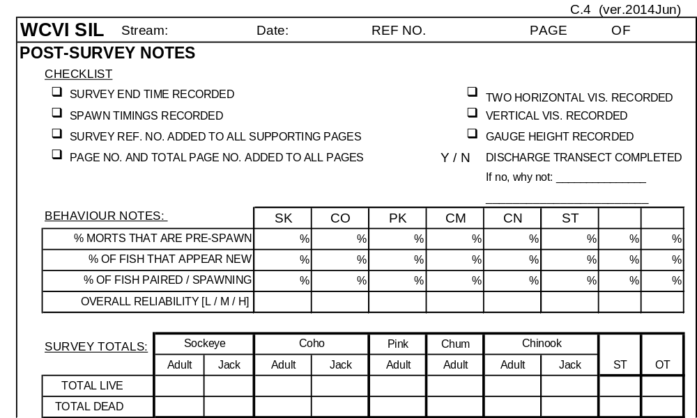

BEHAVIOUR NOTES: For each species:
- % MORTS THAT ARE PRE-SPAWN: Record the percentage of the dead fish observed that died prior to spawning, (i.e. gametes present).
- % OF FISH THAT APPEAR NEW: Record the percentage of the fish that appear to have just started their stream residency.
- % OF FISH PAIRED / SPAWNING: Record the percentage of the fish that are paired and / or spawning.
- Overall Reliability: Record your confidence (Low / Medium / High) in the data for species. Poor visibility, species ID problems, few surveyors, etc., all contribute to Low reliability. Low reliability does not necessarily mean that you feel the count is an under estimate.

SURVEY TOTALS: For each species:
- TOTAL LIVE: Record the sum live fish from each row of the C.2 pages
- TOTAL DEAD: Record the sum dead fish from each row of the C.2 pages

C.4 back - Post survey summary
At the end of the survey, complete the following questions which provide additional information and help to clarify details which may be relevant to analysing the SIL data.
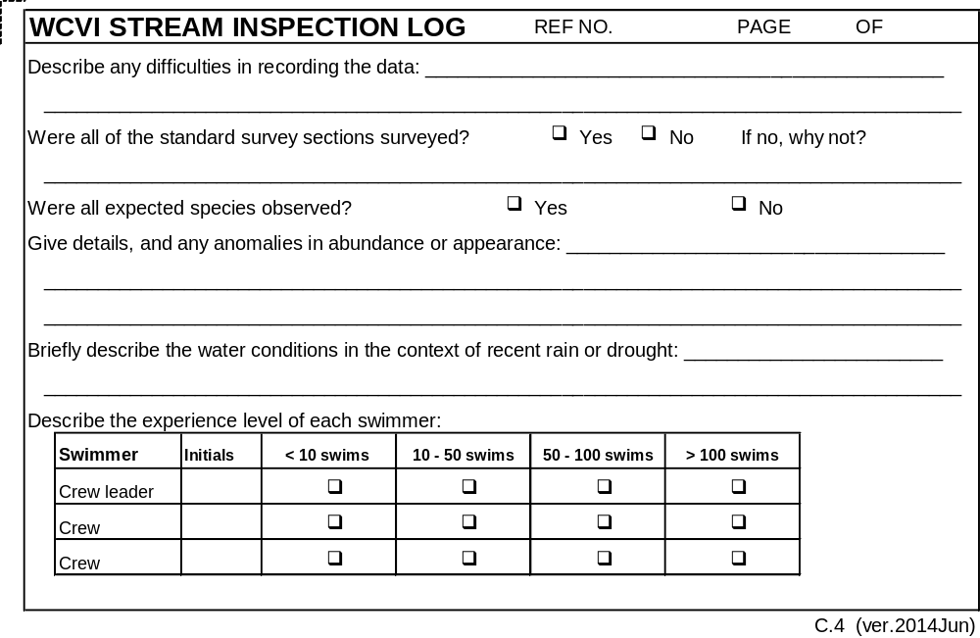

Example of a completed SIL
In this example, there has been an extended dry spell and tags have been applied to Chum to estimate abundance and Survey Life.
